Generate Three Address Code
AIM
To write and execute a C program to generate Three Address Code (TAC) for a given arithmetic expression using stacks and operator precedence.

SOFTWARE REQUIRED
Software: Dev-C++
Programming Language: C

PSEUDOCODE
Step 1: Start the program.
Step 2: Initialize the operator stack, operand stack, and temporary variable counter.
Step 3: Separate the target variable from the right-hand-side expression using the assignment operator (=), if an assignment is present.
Step 4: Scan the expression from left to right, ignoring whitespace characters.
Step 5: If an operand (variable or constant) is encountered, push it onto the operand stack.
Step 6: If an opening parenthesis '(' is encountered, push it onto the operator stack.
Step 7: If a closing parenthesis ')' is encountered, process operators until the matching opening parenthesis is found, then remove the opening parenthesis.
Step 8: If an arithmetic operator (+, -, *, or /) is encountered, process operators with higher or equal precedence from the operator stack before pushing the current operator.
Step 9: To process an operator, pop the operator and two operands, generate a temporary variable (t1, t2, ...), print the TAC instruction, and push the temporary variable onto the operand stack.
Step 10: After scanning the expression, process all remaining operators on the operator stack.
Step 11: Pop the final result from the operand stack and assign it to the target variable, if one was specified.
Step 12: Display the generated Three Address Code and stop the program.

OUTPUT
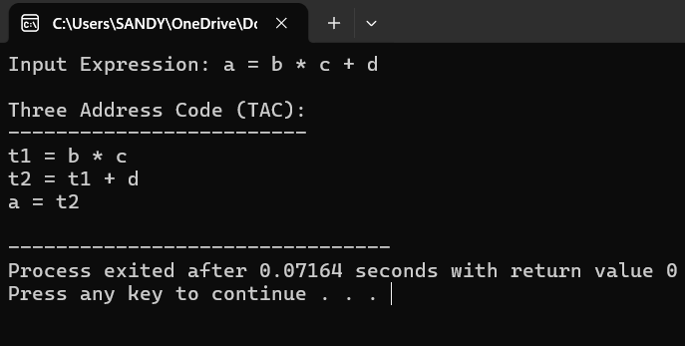

RESULT
Thus, the C program was successfully executed in Dev-C++ to generate Three Address Code (TAC) for the given arithmetic expression using stacks and operator precedence.

